Representing a Cultural Artifact from the Islamic Empire
Grade Level: 7
Subjects: World History
Estimated Time of Completion: 2 class periods

- Instructional Objectives:
  - Students will have the opportunity create a drawing of an Islamic artistic, architectural, or scientific cultural artifact from the height of the Islamic Empire.
  - Students will have the opportunity to describe the design as representations of life in Islam during the 11th and 12th centuries.
  - Students will have the opportunity to create a museum description for their artifact including information gathered from research about the Islamic Empire.
  - Students will have the opportunity to share their findings with their classmates.

- Standards
7.8 Examine and summarize the contributions Muslim scholars made to later civilizations in the areas of science, geography, mathematics, philosophy, medicine, art, and literature. (C, G, H)
- Materials Needed:
  - iPads with Internet access (or library resources)
  - 11"x 17" white drawing Paper (or other size)
  - Colored ½-sized poster board
  - Colored pencils, markers, crayons, rulers, glue or mounting tape
  - (Introductory Video: Islam: Empire of Faith Part Two) (Video cue: 35.20 – 40:05)
  - Cultural Artifact and Description Project Scoring Rubrics (See below)
  - Project Sample Page (see below)

- Procedures:
Overview:
This lesson allows students to do independent research on aspects of Islamic art, architecture, and science. Students will have the opportunity to create a graphic representation or drawing and a museum description of the item they choose to study.

Students will view the introductory video (Islam: Empire of Faith Part Two video cue: 35:20-40:05) and answer the following questions:

Name one artifact Muslims made extremely well according to the video? (ER: textiles / fabrics)

What is evidence that Muslims made excellent fabrics? (ER: They were used by Christians for their saints’ relics)
How were Muslim fabrics superior to those used in Europe at the time? (ER: They were softer, finer, not coarse)

Tell Students:

“You will choose one item or achievement from Islamic history. Your item may be part of Islamic science, mathematics, arts, architecture, fashion, design, calligraphy, carpets, or textiles. Once you have chosen your item, research it to find out the following information:
- When and where was it designed? (Date, Location)
- How was it made? (What materials were used)
- What was its purpose?
- How was it used in Muslim culture and how is it used today?

Once you have researched your item, represent it graphically (with drawing) on a white paper. Write a description of your item like the descriptions of things that are posted in museums. Each description must state:

- Materials used
- Date of origin
- Place of origin
- Meaning of design
- Importance to Islamic Empire

You will have time today and tomorrow to research using the Internet, create your drawing, and craft your description.”

Allow students to read the rubrics below and have access to the links below.

Suggested starting places:

Art of the Islamic World

Clothing and Fashion in the Abbasid Empire

Overview of Islamic Science

Islamic Architecture

Examples of Islamic Architecture

Islamic Arts and Architecture Organization: Oriental Rugs

Islamicity.com: Islamic Art and Architecture

The University of Calgary: The Islamic World to 1600: The Arts, Learning, and Knowledge

Islamic Textiles at ArtLondon: Pictures of textile designs

Museum Associates, Los Angeles County Museum of Art: Islamic Art page

Project Sample:

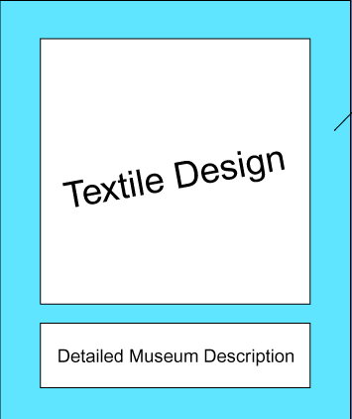
Posterboard background

Scoring Rubric for Cultural Artifact

Score | 5 | 4 | 3 | 2 | 1
Criteria | Above and beyond. Design is very fresh and original, very neat, and historically accurate. Evidence of extra effort. | Design is well done, neat, and shows research for historical accuracy. | Design is adequate, slightly messy, with adequate historical relevance. | Design shows minimal effort, is messy, and has very little historical relevance. | Little time and effort went into this design.
Scoring Rubric for Informative Description below the drawing
Score | 5 | 4 | 3 | 2 | 1
Criteria | Above and beyond. Detailed description shows extensive research and high-level synthesis of information. Very neat. Free of errors. | A quality description. Shows good research and effort. Neat and error free. | An adequate description. Shows some research. Somewhat messy. Minimal errors. | This description required very little research outside of class. Messy. Contains several errors. Minimal effort. | This description was based on the video only. Very messy, or incomplete.

